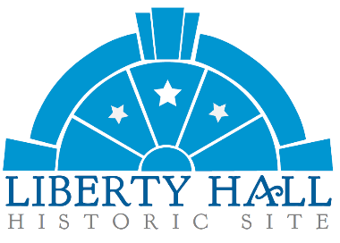
Bourbon & Browns 2026
Sponsorship Reply Form
Saturday, April 25th

Due by February 15th to be listed on the invitation.
(Please note: Only Palladian Sponsors and above will be listed on the invitation)

Sponsor Name: ______________________________Contact: ___________________________________
Mailing Address: ____________________________ City: ____________ State: ____ Zip: _____________
Phone: ___________________________ Email: ______________________________________________
Choose a Sponsor Level
- Liberty Hall Sponsor $10,000+ Palladian Sponsor $1,000 - $2,499
- Orlando Brown Sponsor $5,000 - $9,999 Capital Sponsor $500 - $999
- Keystone Sponsor $2,500 - $4,999 Cornerstone Sponsor $250 - $499

AMOUNT: ______________________

Indicate Your Method of Payment
- Check (enclosed) Payable to LHHS – Memo Line: B&B Sponsorship
- Credit Card (complete form below)
If you prefer to pay in installments, please call (502)227-2560 to make arrangements.

Card Information
Name on Card: ______________________________________ Card Type: ____________________

Card #: ______________________________________ Exp. Date: ________________ Code: ______

Signature: _____________________________________ Date: ______________________________

Please send this form to:
LHHS, 202 Wilkinson St., Frankfort, KY 40601
or Email info@libertyhall.org with subject line - B&B Sponsor Form

